Command:

for $b in books/book

where $b/year = "NaN"

return ($b/name/text(), $b/writer/text())

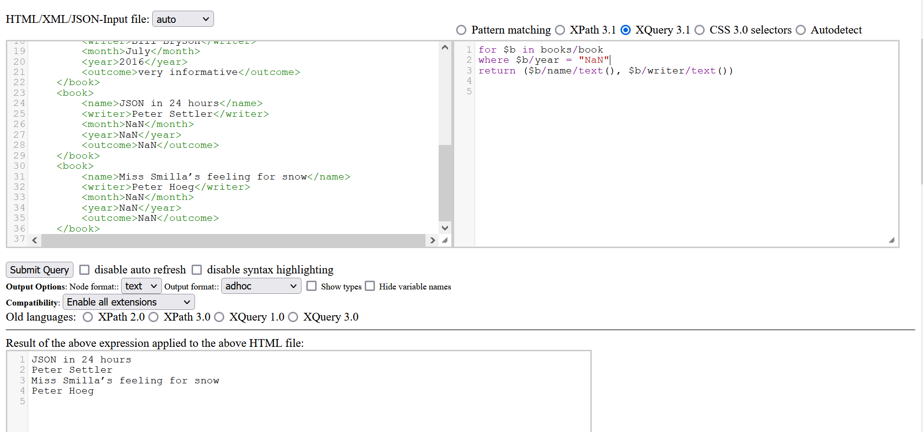Screenshot: